Case Resolution

1. **Functional Requirements:**

* Create a vending machine app to purchase soda and perform following actions: - Developed
  + Insert a quarter
  + Remove a quarter
  + Push the desired soda button
  + Dispense the soda
* Store each soda purchase so the information can be reviewed at a later date. - Developed
* Retrieve the soda count from inventory - Developed
* Support the possible addition of new functionality such as giveaways or contests. - Developed
* Machine selling Process should have the following status: - Developed
  + No Quarter
  + Has Quarters
  + Soda Sold
  + Out of Soda

**Additional Functional Requirements (just for the architecture to support in the future):**

**For the Vending Machine:**

* Accept $ 1 Dollar (configurable option that can be turned on or off). - Developed
* Register a claim if something goes wrong with the purchase. – Just considered in the architecture but not developed.
* Capture customer feedback – Just considered in the architecture but not developed.

**For the Vending Owner:**

* Provide an Admin Dashboard for the owner to:
  + View a Sales summary by date range - Just considered in the architecture but not developed.
  + View Stock/Inventory of products – Just a high level view was developed
  + Manage Stock and Replenish Orders - Just considered in the architecture but not developed

1. **Software Design**

**Component Diagram (Architecture)**



**Entity Relationship Diagram**



**State Diagrams**

* Sale Process Statuses

Original Statuses per Requirement considered “No Quarter” and “Has Quarter”, I changed them to be more general “No Money” and “Has Money”



* Product Statuses



**Wireframes walk through**

* Soda Vending Machine App

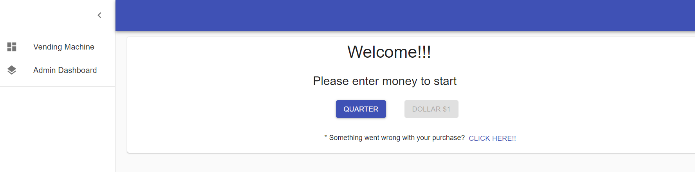

Configurable option that can be turned on or off based on a Setting value

Admin Dashboard>Setting

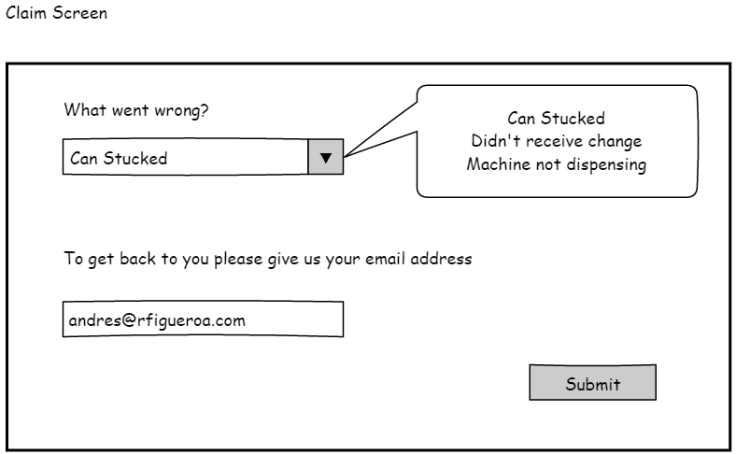

Supported by the architecture, it wasn’t developed.

After inserting (selecting) Quarter or Dollar, screen below displays

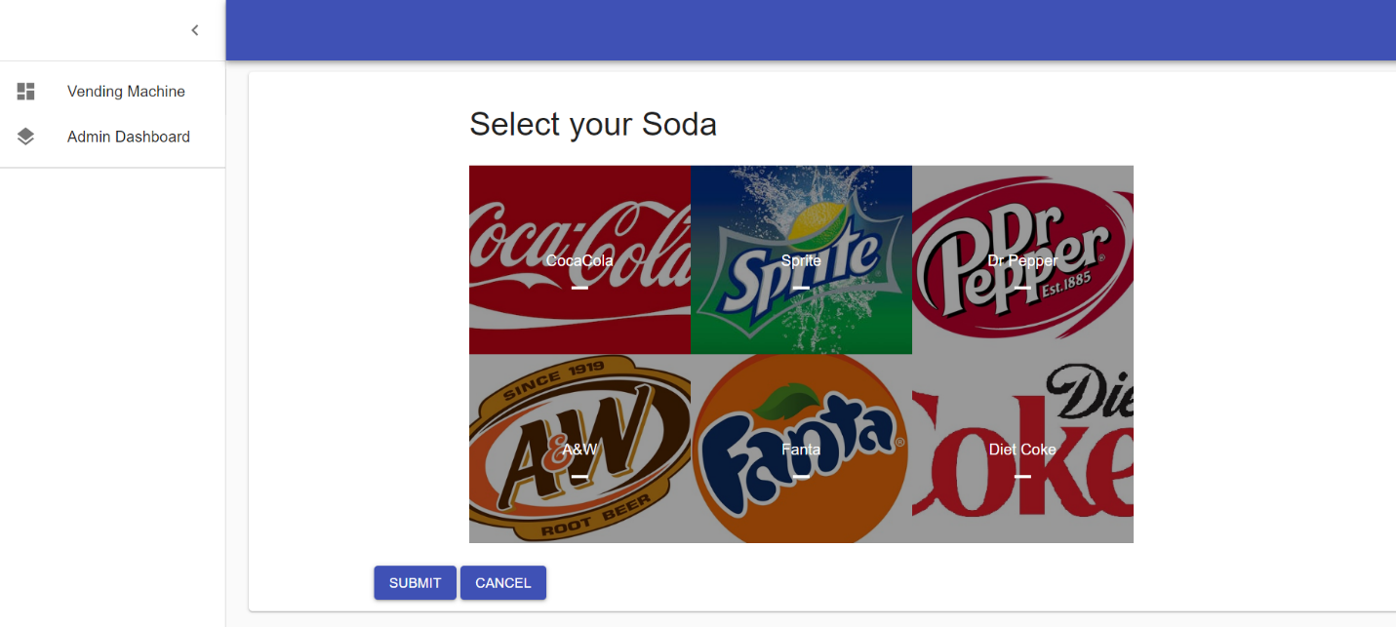

Click Submit to complete Soda selection

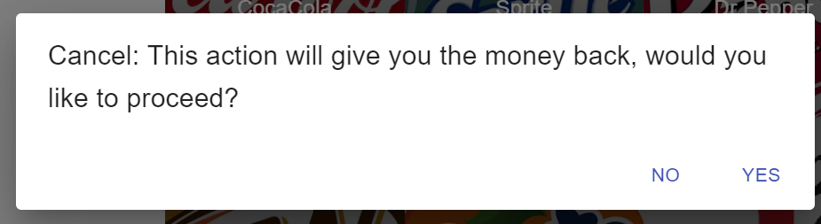

Customer selects a Soda and “Submit”

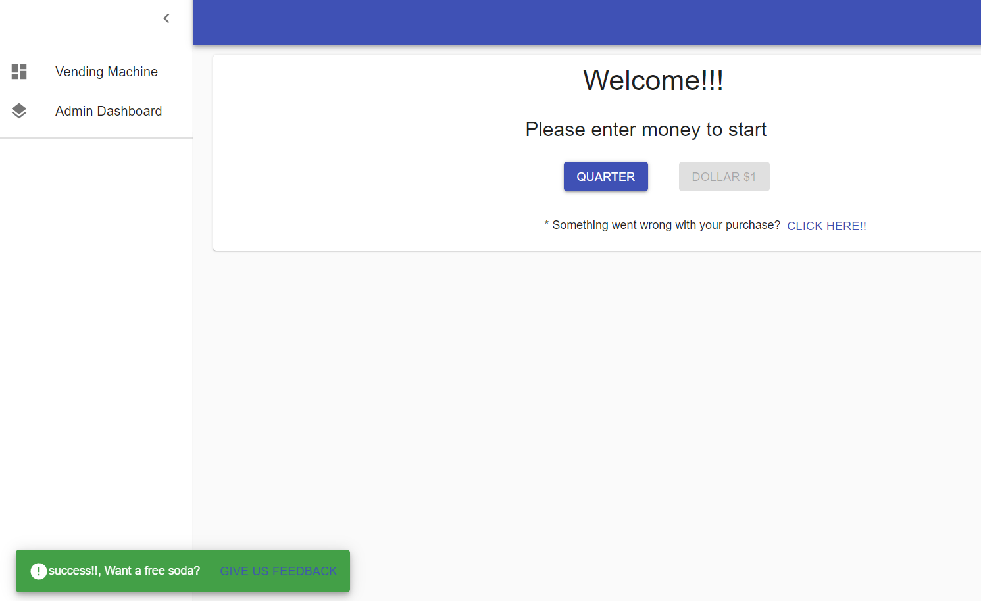

Displays message at the bottom and after a few seconds disappears

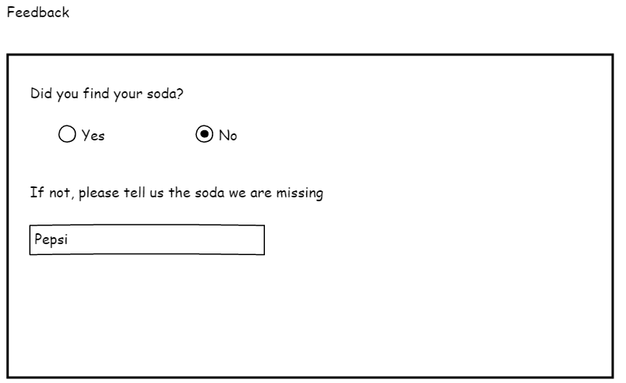

Supported by the architecture, it wasn’t developed.

* Admin Dashboard

**Settings**

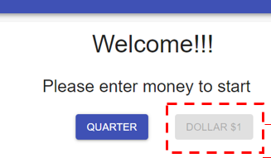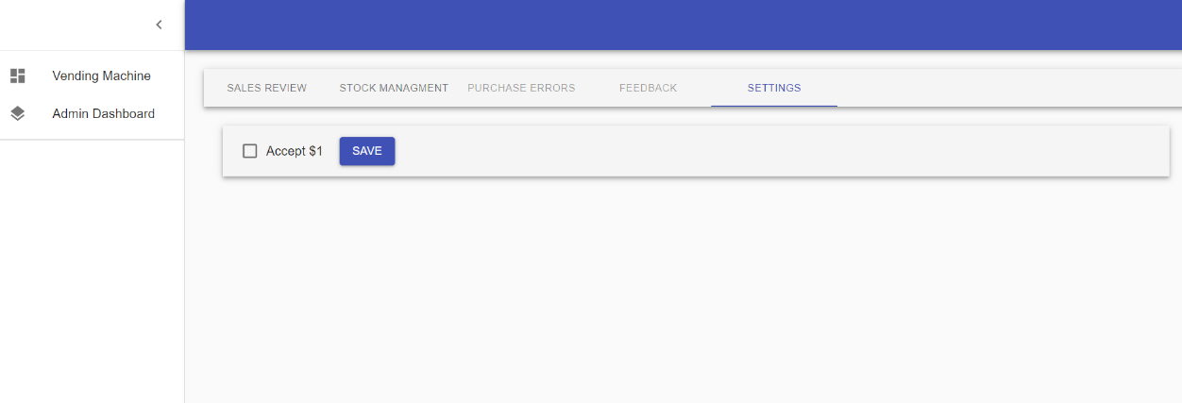

Enables/Disables Dollar button

**Stock Management View**

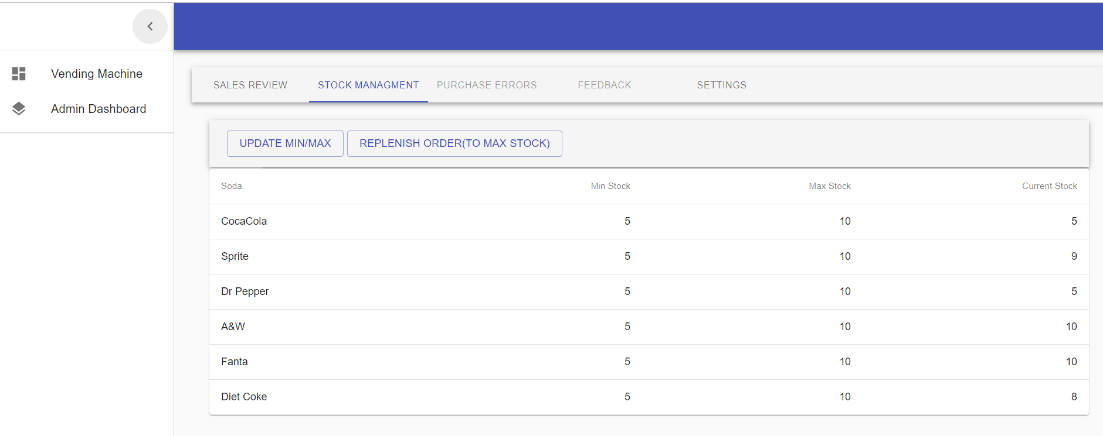

Didn’t develop these

**Sales View**

* I Didn’t develop this but architecture supports below functionality:

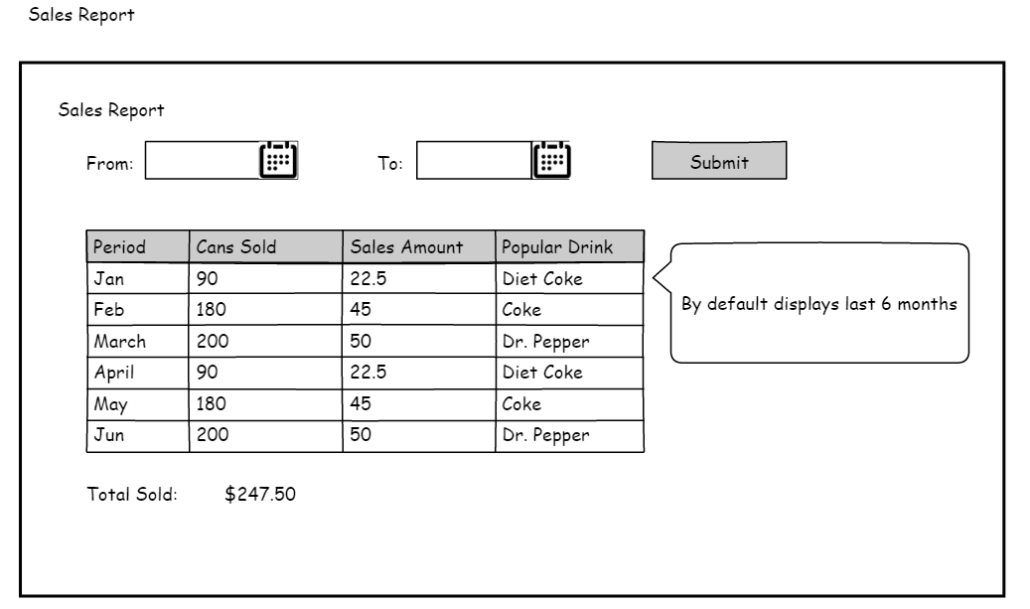

**Note:** I found additional features for the Dashboard but I didn’t develop so I just disabled them.

**e.g.:**

* + **Update Min/Max Stock,** allow Admin user to update the product min and max
  + **Replenish Order (To max stock),** allow Admin user to replenish an order to the max stock.
  + ***Purchase Error*** allows the Admin user to review the customer claims and send Promo codes to customers for next time they use the machine. (just an idea)
  + ***Feedback*** allows the Admin user to review customer’s feedback provided, the question I added was to understand customer’s soda preferences for example.